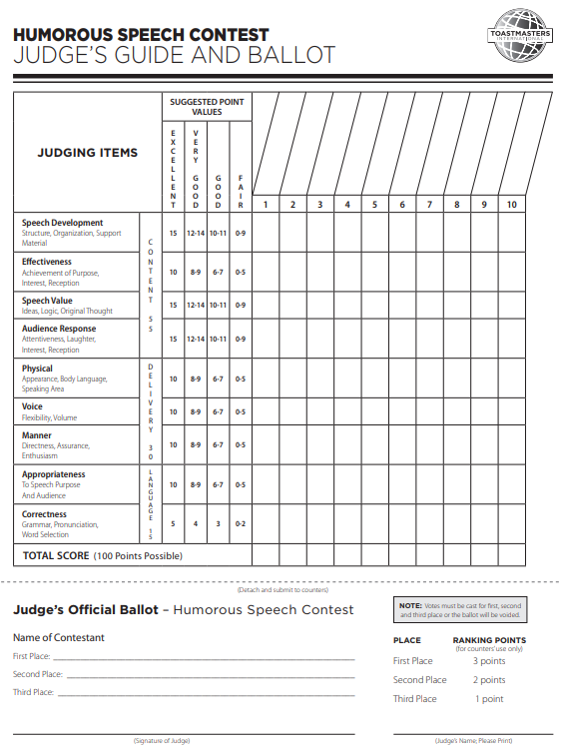

**Humorous**

**Speech Contest**

**District 48**

**Club, Area, Division Info**

**Day / Date / Time**

**Location**

#### Hillsborough Community College English Dept Presents:

Lorem Ipsum Dolor

[Date and Location]

**For Upcoming Contest Information**

***Visit*** [***www.district48.org***](http://www.district48.org) ***> District Events >   
Area Contests and Division Contests***

***All Division winners will advance***

***to the District Contests at our***

***2019 Spring Conference***

***Waves of Opportunity***

***April 26 – 28***

***Tampa Airport Marriott***

***4200 George J Bean Parkway, Tampa, FL 33607***

**Name, credentials**  
*Contest Chair*

**Name, credentials**  
*Contest* Master

**Name, credentials** *Chief Judge*

**Name, credentials** *Timer*

**Name, credentials** *Timer*

**Name, credentials** *Ballot Counter*

**Name, credentials** *Ballot Counter*

**Name, credentials** *Ballot Counter*

|  |  |  |
| --- | --- | --- |
| **Speaking Order** | **Name** | **Final Results** |
|  |  |  |
|  |  |  |
|  |  |  |
|  |  |  |
|  |  |  |
|  |  |  |
|  |  |  |
|  |  |  |

**Contestants**

**Humorous**

**Speech Contest**

**Contest Date**