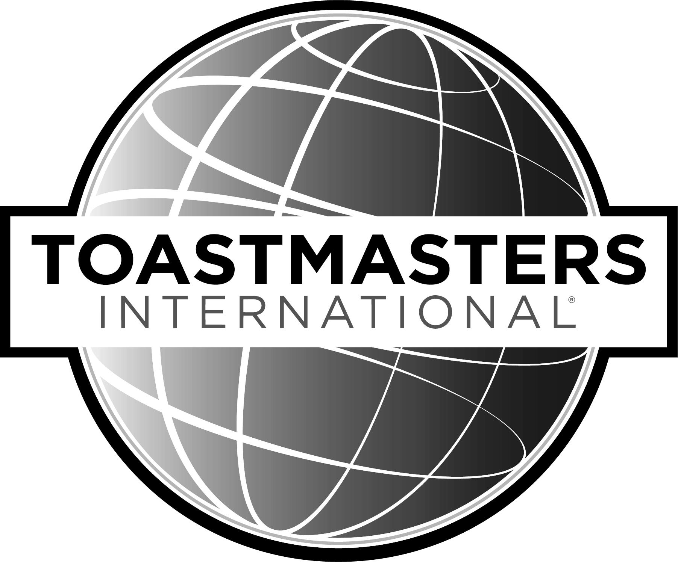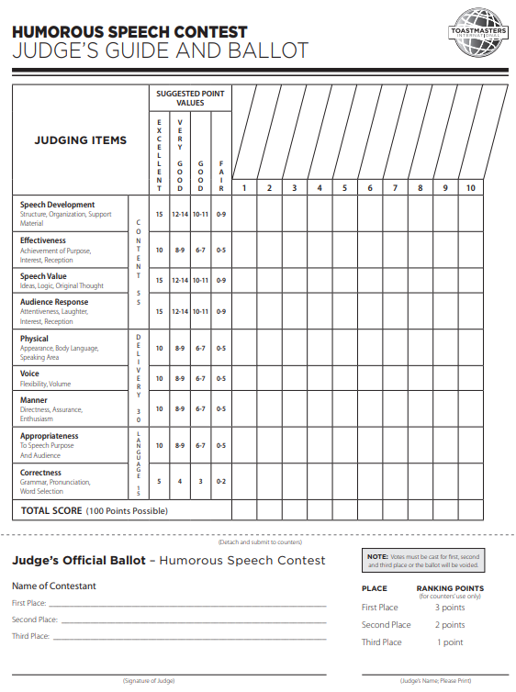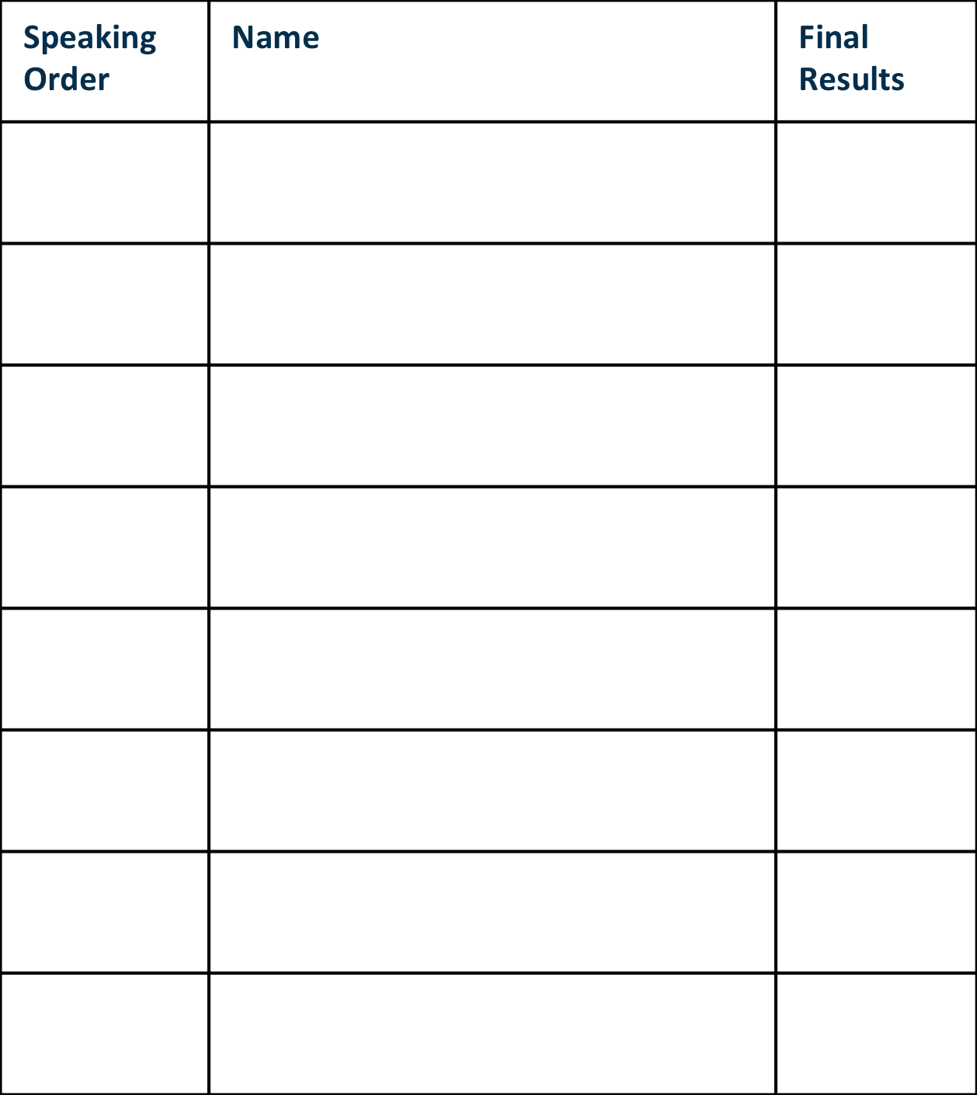

**District 48**

**Club, Area, Division Info**

**International**

**Speech Contest**

**Day / Date / Time**

**Location**

**For Upcoming Contest Information**

***Visit www.district48.org > District Events >   
Area Contests and Division Contests***

***All Division winners will advance***

***to the District Contests at the***

***2019 Spring Conference***

***Waves of Opportunity***

***April 26 – 28***

***Tampa Airport Marriott***

***4200 George J Bean Parkway, Tampa, FL 33607***

**International**

**Speech Contest**